Coventry Association for International Friendship

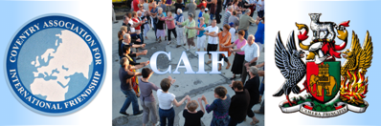

AGENDA – THURSDAY 20th NOVEMBER 2025

GENERAL MEETING
Start time: 18.30, Council House

- Chair’s Welcome (Ram)
- Apologies (Linda)
- Minutes and Matters Arising (All)
- Treasurer’s Report (Paul)
- Correspondence and Secretary’s Report (Linda)
- Starke Photographic project & Visit - report (Dave)
- November Remembrance events and visitors - update (Nikolai)
- Dresden Creatives visit to Coventry in October – report (Clive)
- CAIF at the LMPC’s Peace Award & School of Sanctuary Accreditation-Information Session, 16 October 2025 – report (Michael)
- T.U.D.O.R.S. Visit (February 2026) including request for financial support (Dave & Nikolai)
- Meschede/Vannes friendship link – proposal to host a combined visit (Dave)
- Albany Theatre – Alan Pollock’s proposed A.C.E. funding bid to include a project on Twinning
- Cities of Memory Network:
- The Dunkirk Appeal
- The next Symposium (to be held in Marzabotto and Bologna in October 2026)
- A.O.B.

