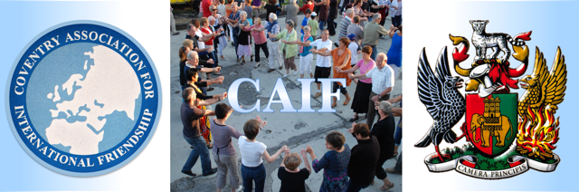

COVENTRY ASSOCIATION
FOR
INTERNATIONAL FRIENDSHIP

The story of a unique people-to-people
organisation

Coventry Association for International Friendship

President: The Lord Mayor of Coventry
Chair: Councillor Ram Lakha, O.B.E.
Vice Chair: Mary Goodwin
Secretary: Linda Hirons
Assistant Secretary: Dave Hirons
Treasurer: Paul Fernandez-Montes

C.A.I.F. is a link with the world beyond the UK’s borders through meetings, hosting opportunities and international travel exchanges.

To enquire about C.A.I.F. or to become a member send an email or visit our website:
email: caif18@btinternet.com
website: www.caif.co.uk
facebook: caif@caifers

Coventry Inspires ... Peace & Reconciliation

The Aims of the Coventry Association for International Friendship (C.A.I.F.), formerly the Coventry Committee for International Understanding (C.C.I.U.).

- To bring together organisations and individuals to promote international friendship and understanding and to create closer ties between the citizens of Coventry and the people of its twinned and linked towns, especially in promoting exchange visits.

- To co-operate with Coventry City Council, in fostering international goodwill.

- To enlist, foster and maintain links with associated organisations and individuals. The Association may co-operate and may affiliate to other organisations in the furtherance of these aims and objectives.

- To encourage and support young people in the furtherance of these aims and objectives.

Introduction
The name of Coventry is well known in many parts of the world, as a symbol of ‘Peace and Reconciliation’.
Coventry’s renown for this dates back to early in World War Two, when the city was heavily bombed on the night of 14th/15th November 1940. Provost Richard Howard famously stood in the ruins of the City’s Cathedral, dedicated to Saint Michael, and prayed, “Father, forgive”. This spirit of reconciliation led to the formation of the ‘Community of the Cross of Nails’, which today has many international members.
Civic links with towns and cities abroad - starting with those heavily ravaged by the war - were formed, in order to foster international friendship and understanding. Town twinning, as these ties were called, became a model followed by other towns and cities in the UK and abroad, which increased Coventry's reputation as a standard bearer for world peace.
The post-war reconstruction of the city centre was widely admired and as the rapid growth of population continued throughout the 20th Century, workers were drawn to its industries from all parts of the United Kingdom and Ireland, from the islands of the Caribbean, from the Indian Continent and from the European mainland and beyond. Consequently, Coventry has become a multi-cultural city, recognised world-wide for its tolerance and international outlook.
This is the setting in which C.A.I.F. exists today.
WHAT WE DO
- We maintain friendship and cultural links developed by the Association over more than 60 years.
- We make international exchanges – through hosting and visiting.
- We share in social activities – making greetings, eating together and talking and engaging in artistic and cultural activities.
- We make visits to sites of common cultural and historical interest.
- We share in remembering the suffering and destruction caused by acts of war.
- We work to raise awareness in young people of the need for Peace and Friendship today.
- We support humanitarian efforts at home and abroad.
- We endeavour to enhance Coventry’s role as a pioneer and leader in the Twin Cities movement.
- We work closely with Coventry City Council to further its aims for international friendship and co-operation.
- We work with partners in Coventry to further our mutual aims for Peace.
- We link with arts groups and cultural networks to support creative activities, at home and abroad.
- We act as a conduit for information between existing and potential partners, at home and abroad.
- We support deserving causes with financial donations using our Hazel Lynn Fund.
- We contributed to Coventry as UK City of Culture 2021 and will work to secure the legacy of Coventry as an important cultural and artistic centre in the UK.
A short history of the formation of C.A.I.F.
With the approach of 1962, many events were being planned for the year of the consecration of the new Cathedral, but civic leaders were very concerned at the growth of tension between East and West, vividly exemplified by the construction of the Berlin Wall. William Callow, the Lord Mayor, decided to convene a conference of representatives from twenty-two towns which had friendship ties with Coventry.
Alderman George Hodgkinson later wrote: "It might have seemed impertinent for the Mayor of an English provincial town to want to do something about a growing, explosive situation ... (but) he had the temerity to go over the heads of top politicians with an appeal to the grass roots of the community in each of these towns."
The outcome was that “The Lord Mayor's Conference” was convened in Coventry which issued a 9-Point ‘Peace Appeal’. This stressed the importance of "people-to-people" contacts and urged local authorities to widen the links of international friendship to include professional, cultural and educational bodies –
"So that we can at least begin to understand one another"
Point Six of the ‘Appeal’ stated:
"We recognise that we are only ordinary people, but we believe that we represent the feelings of a vast number of ordinary citizens. It is not sufficient to leave the discussion of problems to top summit levels. This is an irresponsible attitude. All of us must do everything in our power to study the facts, to believe the best of our neighbours, to refuse to indulge in negative talk or thinking ... "
In the following year the proposal for a permanent peace organisation received community support at a delegate meeting in March 1962 and, at a further meeting in St Mary's Hall, a ‘Constitution’ was approved. In October of the same year, the Cold War almost turned into real, atomic war, when the Soviet Union provided Cuba with missile equipment which could be viewed as designed for either defensive or offensive use.
The new organisation was called a ‘Committee’ because it consisted of representatives of an extremely wide range of community bodies - about eighty-five in all - including the Coventry Cathedral and the Roman Catholic Church, the Free Churches and The Quakers, the United Nations Association, the Mid-Warwickshire Federation of Townswomen's Guilds, the Business and Professional Women's Club, Coventry French Circle, Godiva Harriers, the College of Education, Coventry Works Football Alliance, Coventry Teachers' Association, Coventry and District Angling Association, and many trade union bodies.
Most of the political parties were represented, but the Coventry Committee for International Understanding (C.C.I.U.) never followed any party-political agendas. Its keynote, in the words of Mr. Will Rose, the Vice-Chairman, was that "International friendship and understanding, to be valuable, must not be limited by prejudices." It admitted individual members later on, as well as representatives of organisations.

At an early stage, the Principal of Coventry Art College, David Bethel, designed a badge showing ‘The Phoenix’ reborn from the flames and ashes, surrounded by olive branches.
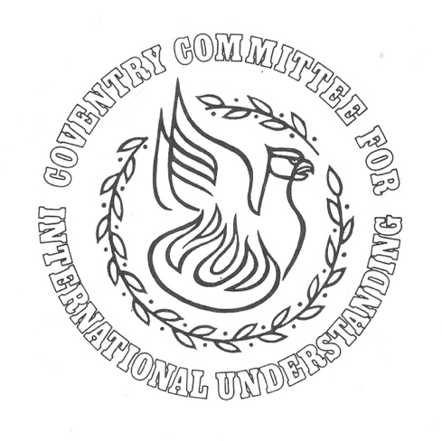
A list was drawn up of people who were willing to offer hospitality to visitors from overseas and all towns with which Coventry had friendship links were informed of the creation of the Committee and invited to establish relations with it.
Within little over a year, the Kiel Youth Orchestra, a delegation from Volgograd, and larger groups from Czechoslovakia and Meschede in Germany's Sauerland were received in Coventry. An exhibition of ‘Children's Art’ was organised in the early years with the pictures coming from sixteen towns in three continents. After 20,000 people had seen these in the Herbert Art Gallery, they embarked on a tour of other towns in Europe which lasted for at least two years. The ‘International Children's Camp’ at Corley, organised by the City Council in 1965, brought together forty-six children and ten adults from seven different countries.
Over the years, C.C.I.U. sent groups to and received groups from a large number of towns, mainly in Europe, including from Caen, St Etienne, Graz and Bologna, as well as from the ever-present Kiel and Meschede. Exchanges also took place with the twinned towns of Coventry, Connecticut and Coventry, Rhode Island, USA.
An early concern of the C.C.I.U. was how to maintain a youth presence in the organisation and there were many visits abroad by, for example, young people travelling to Kiel to play a football match, or to Arnhem to present English folk-dancing. However, it was often difficult to build on such exchanges after the initial event.
*
Rather, the maintenance of C.A.I.F. as an organisation has tended to draw on the commitment of a core of older people, initially those strongly motivated by their experiences of World War Two. Subsequently, it has been supported by those enthused by the idealism of international friendship and understanding and by the pleasure and delight of close companionship with people of other countries and societies in their own homes.

Sixty years on
Exchange visits as understood by C.A.I.F. are very different from the experience garnered by staying in a hotel, in which contact with the local people may extend little further than the exchange of a few words with the receptionist or the barman. A visitor from C.A.I.F. usually stays with a family enabling them to begin to understand their thinking and way of life. English is commonly understood, but foreign language skills can be brushed up and can prove to be more useful than expected. Eating and drinking together, walking with new friends in new environments, and sharing in new cultural experiences, cements friendships, which often last for long after the visit has ended.
The pattern of exchange visits and talks at general meetings has also lasted, even while C.A.I.F.’s membership has ebbed and flowed. As there were so few affiliated organisations, it seemed inappropriate to refer to the organisation as a ‘Committee’ and so its name was changed from the Coventry Committee for International Understanding (C.C.I.U.) to the Coventry Association for International Friendship (C.A.I.F.). Now, in the 21st Century, many of the pioneers of C.C.I.U./C.A.I.F. have fallen away through natural causes. People such as Councillor Dennis Berry, long-term Treasurer John Humphries, member Hazel Lynn - a staunch supporter of the aims of both organisations - and previous Secretaries, John Moore and Pat Trickett, fall into the category of those who are no longer with us but who are remembered with gratitude and affection.
One reason for the fall in membership was that a more relaxed international climate prevailed during the latter decades of the 20th Century and the urgent impulse to make partnerships for peace in the twin cities and towns ebbed away. But, in the latter half of the last decade, 2010-2019, new threats to peace and international co-operation have emerged and a renewed consciousness of the need to sustain good international relations between the peoples of the world has emerged.
To this end, C.A.I.F. has been busy – renewing old links of international friendship with Dresden and Kiel in Germany and reinforcing the long-established link with Volgograd in Russia (sadly “paused” in March 2022 by a decision taken unanimously by Coventry City Council). At the same time, long-standing links of friendship have been sustained and are on-going with the friendship towns of Meschede in the Sauerland of Germany and with Vannes in Brittany, France. The latter has been one of C.A.I.F.’s closest partners and numerous group exchanges have taken place producing a wealth of personal friendships.
In the recent past Graz (in Austria) and Bologna (in Italy) have been visited, in order for members of C.A.I.F. to reach out to two of Coventry’s twins for the re-establishment of exchanges. Contacts also exist with Sarajevo (in Bosnia-Herzegovina) and Belgrade (in Serbia), with whom, it is hoped, one day new friendship links will be established. Similarly, the seeds of a link with Cork (in Ireland) have been sown through support given to the Coventry-Cork Poetry Exchange. We are also ever-hopeful that the strong links with the three Coventry towns in the US, can be re-developed, in spite of the fact that distance makes exchanges more problematic owing to the cost of travel.
A group of C.A.I.F. members visited Volgograd in 2001 and enjoyed generous hospitality, which was returned the following year in Coventry, and another C.A.I.F. visit occurred in 2003 on the 60th anniversary of the victorious Battle of Stalingrad. In November 2019, the 75th Anniversary of the twinning of Coventry and Volgograd was celebrated, notably with a visit to Coventry by a group of young dancers from our Russian twin town in which C.A.I.F. played a key, organisational, role.
Various reciprocal visits have taken place between Coventry and Dresden, with C.A.I.F members enjoying the delights of the historic city on the Elbe, exploring the artistic treasures of the Zwinger Gallery, and meeting with the City’s Mayor, while artist and poet exchanges have also been arranged. Dresden’s “Neuer Chor” performed in Coventry Cathedral and the English girls’ choir, “The Nightingales”, affiliated to C.A.I.F. and directed by our sadly deceased former secretary, Pat Trickett, shared concerts with a German girls’ choir. The atmosphere of friendship was moving. In 2021, as part of the programme of Coventry as the “UK City of Culture”, a Coventry-Dresden Festival was conceived and enacted in Coventry with a wide-ranging programme of events and participants from both cities.
“The Nightingales” sang in a secondary school in Kiel, together with German schoolgirls and one German said -
“Their grandparents were enemies, just look at them now”
Several visits – both to Coventry and elsewhere – have taken place in the company of a group of friends from Kiel and these have laid the basis for what it is hoped will be a greater strengthening of civic and cultural links.
The city of Jalandhar in the Punjab has been proposed as Coventry’s 27th Twin, and, although this is yet to come to a formal fulfilment, it is possible that even more ambitious exchanges might be the result, such as, visits to the Punjab in India. This would, indeed, acknowledge Coventry’s multi-cultural status.
In the recent past, C.A.I.F. has staged a number of concerts during Coventry’s annual November “Peace Month”. Performers have included “The Nightingales” choir as well as other local choirs and artists drawn from Coventry’s many and varied communities. These have often included Coventry’s Polish Choir, “Senza Nome”, directed by the inestimable Joanna Kunda, who is a member of C.A.I.F. Thus, a connection with Poland, notably Warsaw, which was visited in 2011, has been strengthened.
In support of Peace and Reconciliation, C.A.I.F. has held public meetings with prominent speakers on subjects such as Climate Change, the European Union, and the problems being experienced by the people of Palestine and Afghanistan. Senior staff from Coventry Cathedral have addressed C.A.I.F. meetings and parties of C.A.I.F.’s guests have been given hospitality in one of Coventry’s Sikh temples. During 2018, C.A.I.F. was contacted by the Mosul Foundation, an organisation dedicated to the re-building of the historic city in Iraq, who wished to accrue experience and understanding of C.A.I.F.’s work. Since then, a representative of this Foundation has become an active and valued member of C.A.I.F.

A New Phoenix

The ‘Phoenix’ rose again in Coventry and stands as an enduring symbol of the city’s renewal. In the same sense, C.A.I.F. continues to renew itself by spreading the awareness and knowledge of its work as widely as possible amongst the many, diverse and active communities of Coventry.
New faces have appeared on C.A.I.F.’s Executive Committee, and new members have been attracted as C.A.I.F.’s activities have widened in the city as well as new relations being established with some of Coventry’s older twin cities.
Whilst long-standing campaigners have sadly passed away, new members are all keen to re-invigorate C.A.I.F.
*
C.A.I.F.’s ties with the City Council have always been close - the Chair is always a City Councillor, and the President is the Lord Mayor of the day. A modest Council grant helps with the costs of running C.A.I.F. but does not subsidise the members, who pay their own subscriptions and travel expenses on exchange visits. From within the Association’s funds an allowance is paid to those who accommodate guests from abroad.

Tomorrow’s Peace
Under the banner of “People-to-People” C.A.I.F.’s aim is to bring about international meetings and exchanges which recognise a common humanity, regardless of differences in nationality, ethnicity or creed. Knowing that war is, essentially, an affront to humanity, C.A.I.F. subscribes to the idea that it is better to talk and co-exist in friendship - with long-term negotiation being the preferred, sane option, to even a few minutes of warfare. C.A.I.F. believes that Coventry’s Peace symbolism has not lost its significance in today’s world, as alarming flashpoints, especially in the Middle East and, more recently, in Europe, continue to occur.
C.A.I.F.’s reason for being is to express the support of ordinary citizens for the concept of twinning. As an Association of people who share in the same ambition for a peaceful world, and who seek to promote peace through friendship and mutual understanding, C.A.I.F. has continued to pursue its influence abroad, where its presence often attracts local attention and media coverage. The challenge is to increase support for and membership of C.A.I.F. by publicising its activities and its purpose which, it is hoped, will lead to more public involvement in both current and future exchanges. Such visits, along with a range of other activities, will continue to promote the objectives of Peace and Reconciliation.
Town twinning was a great Coventry invention, and international “People-to-People” gatherings are an important complement to this.

Three eminent members of C.A.I.F. and/or the C.C.I.U.
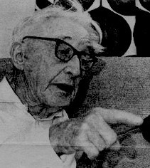
Cllr. George Hodgkinson
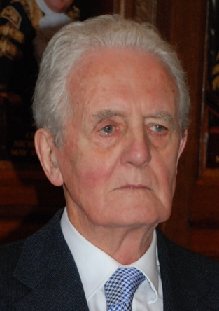
John Moore
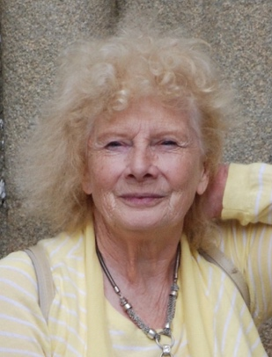
Pat Trickett

The Hazel Lynn Fund
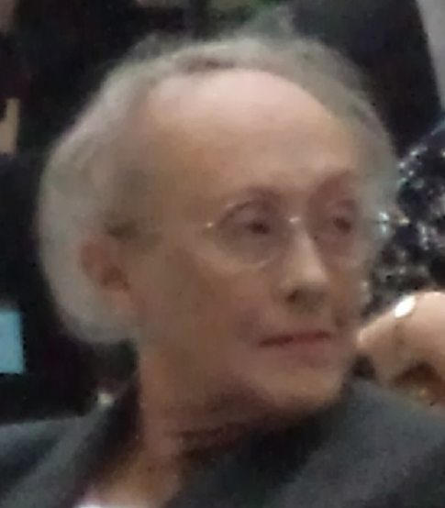
Hazel Lynn was a member and secretary of the C.C.I.U. and a member of C.A.I.F. until her death in 2013.
She bequeathed a large sum of money to C.A.I.F., which has enabled the Association to support a number of initiatives under the auspices of “The Hazel Lynn Fund”
Hazel specified that the bequest be made to C.A.I.F. for -
“Projects which would promote International Understanding, rather than for the general purposes of the organisation".
TWIN CITIES OF COVENTRY
(in order of year of twinning)
CITY YEAR OF TWINNING
VOLGOGRAD, Russia 1944
KIEL, Germany 1947
LIDICE, Czech Republic 1947
SAINT-ETIENNE, France 1955
PARKES, Australia 1956
SARAJEVO, Bosnia/Herzegovina 1957
WARSAW, Poland 1957
BELGRADE, Serbia 1957
CAEN, France 1957
GRAZ, Austria 1957
ARNHEM, Netherlands 1958
DRESDEN, Germany 1959
OSTRAVA, Czech Republic 1959
BOLOGNA, Italy 1960
CORK, Ireland 1960
COVENTRY, Connecticut, USA 1962
DUNAUJVAROS, Hungary 1962
GALATI, Romania 1962
KECSKEMET, Hungary 1962
KINGSTON, Jamaica 1962
GRANBY, Quebec, Canada 1963
WINDSOR, Canada 1963
COVENTRY, Rhode Island, USA 1971
CORNWALL, Ontario, Canada 1972
COVENTRY, New York State, USA 1972
JINAN, China 1983

Coventry Association for International Friendship

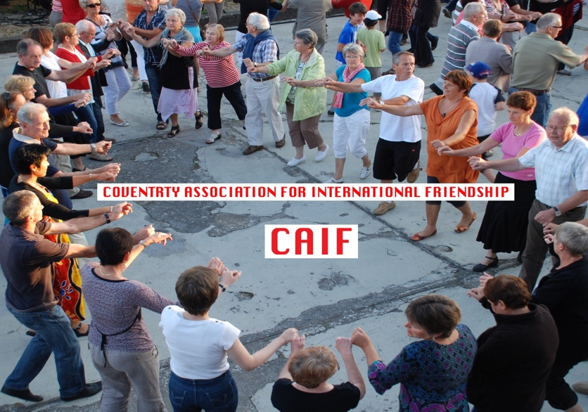

We are a group of people who share in the same ambition for a peaceful world and who seek to promote peace through friendship and mutual understanding.
We meet together regularly for social events & fundraising and take part in exchange visits with similar groups abroad who have cultural links with the city of Coventry.

